# VISVESVARAYA TECHNOLOGICAL UNIVERSITY

JNANA SANGAMA, BELAGAVI – 590 018



**An Internship Project Report**

**on**

***MEDICAL STORE MANAGEMENT SYSTEM***

Submitted in partial fulfillment of the requirements for the VIII Semester of degree of **Bachelor of Engineering in Information Science and Engineering** of Visvesvaraya Technological University, Belagavi

**by**

**ARUNKUMAR NM**

**1RN18IS027**

**Under the Guidance of**

**Ms. Priyanka M R**

**Associate Professor**

**Department of ISE**



**Department of Information Science and Engineering**

## RNS Institute of Technology

##### Channasandra, Dr. Vishnuvardhan Road, RR Nagar Post, Bengaluru – 560 098

2021 – 2022

**RNS INSTITUTE OF TECHNOLOGY**

**Dr. Vishnuvaradhan Road, Rajarajeshwari Nagar post,**

**Channasandra, Bengaluru – 560098**

**DEPARTMENT OF INFORMATION SCIENCE & ENGINEERING**



### CERTIFICATE

Certified that the Internship work entitled ***Medical Store Management System*** has been successfully completed by **ARUNKUMAR NM (1RN18IS027)** a bonafide student of **RNS Institute of Technology, Bengaluru** in partial fulfillment of the requirements of 8th semester for the award of degree in **Bachelor of Engineering in Information Science and Engineering** of **Visvesvaraya Technological University, Belagavi** during academic year **2021-2022**. The internship report has been approved as it satisfies the academic requirements in respect of internship work for the said degree.

|  |  |  |
| --- | --- | --- |
| **____________________** | **_____________________** | **_____________________** |

|  |  |  |
| --- | --- | --- |
| **Ms.Priyanka M R** | **Dr. Suresh L** | **Dr. M K Venkatesha** |
| Internship Guide | Professor and HoD | Principal |
| Associate Professor | Department of ISE | RNSIT |
| Department of ISE | RNSIT |  |

|  |  |  |
| --- | --- | --- |
|  | **External Viva** |  |
| **Name of the Examiners** |  | **Signature with Date** |

|  |  |
| --- | --- |
| **1. ___________________________** | **1. ______________________** |
| **2. ___________________________** | **2. ______________________** |

**DECLARATION**

I, **ARUNKUMAR NM [USN: 1RN18IS027]** student of VIII Semester BE, in Information Science and Engineering, RNS Institute of Technology hereby declare that the Internship work entitled  ***Medical Store Management System*** has been carried out by us and submitted in partial fulfillment of the requirements for the *VIII Semester degree of* ***Bachelor of Engineering in Information Science and Engineering*** *of Visvesvaraya Technological University, Belagavi* during academic year 2021-2022.

Place : Bengaluru

Date : 12/01/2022

**ARUNKUMAR NM**

**(1RN18IS027)**

**ACKNOWLEDGMENT**

At the very onset I would like to place our gratefulness to all those people who helped me in making the Internship a successful one.

Coming up, this internship to be a success was not easy. Apart from the sheer effort, the enlightenment of the very experienced teachers also plays a paramount role because it is they who guided me in the right direction.

First of all, I would like to thank the **Management of RNS Institute of** **Technology** for providing such a healthy environment for the successful completion ofinternship work.

In this regard, I express sincere gratitude to our beloved Principal **Dr. M K Venkatesha,** for providing us all the facilities.

We are extremely grateful to our own and beloved Professor and Head of Department of Information science and Engineering, **Dr. Suresh L**, for having accepted to patronize me in the right direction with all her wisdom.

We place our heartfelt thanks to **Ms. Priyanka M R** Professor , Department of Information Science and Engineering for having guided internship and all the staff members of the department of Information Science and Engineering for helping at all times.

I thank **Mr. RAMESH, TechieAid**, for providing the opportunity to be a part of the Internship program and having guided me to complete the same successfully.

I also thank our internship coordinator **Dr. R Rajkumar,** Associate Professor, Department of Information Science and Engineering. I would thank my friends for having supported me with all their strength and might. Last but not the least, I thank my parents for supporting and encouraging me throughout. I have made an honest effort in this assignment.

ARUNKUMAR NM

# ABSTRACT

The purpose of Medical Store Management System is to automate the existing manual system by the help of computerizing equipment and full-fledged computer software, fulfilling requirements, so that their valuable data/information can be stored for a long period with easy accessing and manipulation of the same. The required software and hardware are easily available and easy to work with.

Our project Medical Store Management System includes login page to get into the home page, addition and deletion of products, customers, employees storing their details into system. Our software has the facility to give the unique id for employees and customers and stores the detail of products and customers automatically. It includes display of products, employees, customers.

The Medical Store Management System can be entered by using username and password entered by the admin. At the front-end we have used PHP, while at the back-end we have used My-SQL server. The interface we have created is very user-friendly. Medical Store Management System, as described above, can lead to error free, secure, reliable and fast management system. It can assist the user to concentrate on their other activities rather to concentrate in record keeping. Thus, it will help organization in better utilization of resources. The organization can maintain computerized records without redundant entries.

|  |  |
| --- | --- |
| **TABLE OF CONTENTS** | |
| Acknowledgement Abstract  Table of Contents List of Figures List of Tables | i ii iii iv v |
| **Chapter 1 Introduction** | **1** |

* 1. Overview of the project
  2. Sub functions
  3. Objectives of project
  4. Introduction to Database Management System
  5. Advantages of DBMS

#### Chapter 2 Software Requirement Specification 3

* 1. Hardware requirements
  2. Software requirements
  3. Xampp
  4. PHP Programming
  5. MySqli

#### iii

Chapter 3 System Design 8

* 1. Schema Diagram
  2. Entity-Relationship Diagram

Chapter 4 Implementation 11

* 1. Table Structure
  2. Code for PHP Connection
  3. Triggers
  4. Stored Procedures

#### Chapter 5 Results and snapshots 16

#### Chapter 6 Testing 22

#### Chapter 7 Conclusion and Future Enhancement 24

#### Bibliography 26

|  |
| --- |
| **List of Figures Page no.** |
| Figure 4.1: Schema Diagram 12 |
| Figure 4.2 Entity-Relationship Diagram 13 |
| Figure 6.1: Login Page 19 |
| Figure 6.2: Home Page 20 |
| Figure 6.3: Product details 20 |
| Figure 6.4: Customer details 21 |
| Figure 6.5: Bill generation using name 21 |
| Figure 6.6: Bill generation using billing date 22 |
| Figure 6.7: Addition of products 22 |
| Figure 6.8: Details 23 |
| Figure 6.9: Addition of employee 23 |
| Figure 6.10: List of employee 24 |
| Figure 6.11: list of users 24 |

**iv**

**List of tables Page no.**

|  |
| --- |
| Table 3.1 Description of XAMPP 8  Table 5.1 Employee 15  Table 5.2 Medicine 15  Table 5.3 Customer 15  Table 5.4 Supplier 16  Table 5.5 User 16 |
| **v** |

# INTRODUCTION

#### Overview of the project

Medical store management system is basically concerned with billing of orders placed by customers, providing details of products available in the medical store, displaying details of customers and staff and updating the quantity of each product in the medical store. The need of this system arose because it is known fact that pharmacy usually has a huge crowd and to handle it manually is quit a tough job. By computerizing it, we will be able to overcome many of its limitations and will be able to make it more efficient. The handling of data and records for such a vast system is a very complex task if done manually. But it can be made much easier if the system is computerized and billing of the orders which contain many products will be handled easily.

#### Sub-functions

* It shows details of products available and enables one to add, delete and update the product, also contains information about customers.
* It provides security, as only admin has permission to access the data and perform operation using login system.
* It automatically updates the quantity of remaining products once the billing is done.
* It enables admin to add or delete customers, suppliers and products. He can also add another admin if needed.

#### Objectives of project

* The objective of this system is to give structural design to pharmacy handling system.
* The project provides functionality and flexibility to pharmacy such that one can operate that system easily and efficiently.
* The project also provides a complete set of solutions for some common and specific ambiguities faced during billing or placing orders.

#### Introduction to the Database Management System

A Database Management System (DBMS) refers to the technology of creating and managing the database. Basically, a DBMS is a software tool to organize data in the database. The main

aim of DBMS is to supply a way to store and retrieve database information that is both convenient and efficient. By data, we mean known facts that can be recorded and that have embedded meaning.

Database systems are meant to handle large collection of information. Management of data involves both defining structures for storage of information and providing ways to do manipulation of the information that is stored in the system.

#### Advantages of DBMS

A Database Management System has many advantages over the traditional file systemized in earlier days, such as:

* + - Data independence: Application programming should be as free or independent as possible from details of data representation and storage. DBMS can supply any abstract view of the data for insulating application code from such facts.
    - Efficient data access: DBMS uses a mixture of concepts and techniques for storing and retrieving data and this feature becomes important in cases where the data is stored on external storage devices.
    - Data integrity and security: If data is accessed through the DBMS, the DBMS can enforce integrity constrains on the data.
    - Data administration: When several users share the data, integrating the administration of data can offer major improvements. Experienced professionals understand the nature of data being managed and can be responsible for organizing the data representation to reduce redundancy and make the data to retrieve efficiently.

**SOFTWARE REQUIREMENT SPECIFICATION**

#### Hardware Requirements

* + - Processor: intel i5 Core Processor
    - RAM: 2GB or more
    - Hard Disk: 2GB or more

#### Software Requirements

Technologies used

* + - Front-end: HTML, CSS
    - Connection: PHP
    - Server: Xampp
    - Back-end: MysSqli

#### Technology used:

This project is developed using the below technologies:

* + - **HTML**: This is used for designing the page layout.
    - **CSS:** This is used for designing of HTML pages.
    - **PHP:** This is used to provide the connection between the front and back ends.
    - **Xampp Server**: This is required for the implementation of PHP code.
    - **Mysqli**: This is the database used at the backend for the implementation of the project.

#### XAMPP

Xampp is a free and open source cross-platform web server solution stack package developed by apache friend, consisting mainly of the apache http server, maria database, and interpreters for scripts written in php and perl programming languages. Xampp stands for CROSS-PLATFORM (X), APACHE (A), MARIADB (M), PHP (P) and PERL (P). It is a simple, lightweight apache distribution that makes it extremely easy for developers to create a local web server for testing and deployment purposes.

Things require to set up a web server are:

* + - Server application
    - Database (mariadb)
    - Scripting language (php)

All these are included in an extractable file. Xampp works on cross-platform, which means it works equally well on Linux, Mac and windows. Since most actual web server deployments use the same components as Xampp, it makes a transition from a local test server to live server easily as well. Initial release of Xampp was on May 22, 2002. The developers were apache friends.

###### Description of XAMPP

|  |  |
| --- | --- |
| **Letter** | **Meaning** |
| **X** | an ideographic letter referring to cross platform |
| **A** | Apache or its expanded form, Apache HTTP Server |
| **M** | MariaDB formerly: MySQL |
| **P** | PHP |
| **P** | Perl |

Table 2.1 Description of XAMPP

#### PHP Programming

PHP is a server-side scripting language designed primarily for web development but also used as a general-purpose programming language. Originally created by Rasmus Lerford in 1994, the php reference implementation is now produced by the php development.

Php originally stood for personal home page, but now it stands for recursive acronym, PHP: hypertext pre-processor. Its paradigm is imperative, object oriented, procedural, reflective. It can be implemented in C language primarily some components of C++. The file name extensions are given as .php, .phtml, .php4, .php4, .php5, .php7, phps. Php code maybe embedded into html or html5 markup, or it can be used in combination with various web template systems, web content management systems and web frameworks.

Php code is usually processed by a php interpreter implemented as a module in the web server or as a common gateway interface (cgi) executable. The web server software combines the results of the interpreted and executed php code, which may be any type of data including images with the generated web page. Php code may also be executed with a command-line interface (cli) and can be used to implemented standalone graphical applications. The standard php interpreter, powered by the zend engine, is free software released under php license.

Php has been widely ported and can be deployed on almost every operating system and platform, free of charge. The php language evolved without a written formal specification or standard until 2014, leaving the canonical php interpreter as a defector standard. PHP includes various free and open-source libraries in its source distribution or uses them in resulting PHP binary builds. PHP is fundamentally an Internet-aware system with built-in modules for accessing File Transfer Protocol (FTP) servers and many database servers, including PostgreSQL, MySQL, Microsoft SQL Server and SQLite, LDAP servers and others.

PHP allows developers to write extensions in C to add functionality to the PHP language. PHP extensions can be compiled statically into PHP or loaded dynamically at runtime. PHP is a general-purpose scripting language that is especially suited to server-side web development, in which case PHP generally runs on a web server. Any PHP code in a requested file is executed by

the PHP runtime, usually to create dynamic web page content or dynamic images used on websites or elsewhere.

#### MySQLi

MySQLi is a Relational SQL database management system.

MySQLi is used inside the PHP programming language to give an interface with MySQL databases. MySQLi is a fast, easy-to-use RDBMS being used for many small and big businesses. MySQLi Extension is developed, marketed, and supported by MySQL.

* MySQL is becoming more popular because of many good reasons-
* MySQLi is released under an open-source license. So, you have to pay to use it.
* MySQLi is a very powerful program in its own right. It handles a large subset of the functionality of the most expensive and powerful database packages.
* MySQLi uses a standard form of the well-known SQL data language.
* MySQLi works on many operating systems and with many languages including PHP, PERL, C, C++, JAVA, etc...
* MySQLi works very quickly and works well even with large data sets.
  + MySQLi is very friendly to PHP, the most appreciated language of web

development it supports large databases, up to 50 million rows or more in a table. The default file size limit for a table is 4GB, but you can increase this (if your operating systems can handle it) to a theoretical limit of 8 million terabytes (TB).

MySQLi is customizable. The open-source GPL license allows programmers to modify the MySQL software to fit their own specific environments

###### MySQLi functions:

* mysqli_connect() – This is used to make the connection between the database and the front end or the software application.
* mysql_query() – This is used to execute a query written in php variable and then executing the query with the database.
* mysqli_real_escape_string() – This is used to convert the posted variable or extracted variable in the form of string.
* header() – This is used to head the page to another page after the completion of the process or operations on the page.
* mysqli_fetch_array() – This is used to retrieve the array from the database and used those values in the front end or do operations on it.
* mysqli_num_rows() – This is used in order to obtain the number of rows in the fetched table or data from the database.

# SYSTEM DESIGN

System design is the process of defining the architecture, modules, interfaces, and data for a system to satisfy specified requirements. System design could be the application of systems theory to product development.

#### Schema Diagram

Schema diagram is the one which shows the dependencies between various attributes used in the table and the dependency on attributes of another table. The database schema of database system is its structure described in a formal language supported by the database management system. The term schema refers to the presentation of data as a blueprint of how the database is constructed. The schema objects do not have a one to one correspondence to physical files that store their information. The primary key is denoted by underlining the attribute and foreign keys are referenced to the corresponding primary key of same or another table.

###### Employee

|  |  |  |  |  |
| --- | --- | --- | --- | --- |
| **Emp_id** | **Name** | **Phone** | **Address** | **Salary** |

**Medicine**

|  |  |  |  |  |  |  |  |
| --- | --- | --- | --- | --- | --- | --- | --- |
| **M_name** | **Exp_date** | **Ch_amt** | **Quantity** | **Costprice** | **Sellingprice** | **C1** | **P_name** |

###### Customer

|  |  |  |  |  |
| --- | --- | --- | --- | --- |
| **Cid** | **Cname** | **Sell_date** | **Quantity** | **Total** |

**Supplier**

|  |  |  |  |  |
| --- | --- | --- | --- | --- |
| **Phname** | **Sname** | **Phone** | **Address** | **Phid** |

###### Users

|  |  |  |
| --- | --- | --- |
| **U_id** | **User_name** | **Password** |

**Figure 3.1 Schema Diagram**

The figure 3.1 shows the schema diagram of the pharmacy database management which contains table’s user, supplier, medicine, customer and employee.

#### Entity Relationship Diagram

The E-R Diagram stands for Entity-Relationship diagram which shows the relationship between the tables and their various attributes involved in the database. Tables are represented using rectangles and relation between tables is represented using diamond shaped structure. The different attributes of each table are shown using oval shaped terminators. The type of relation is specified within the decision loop.

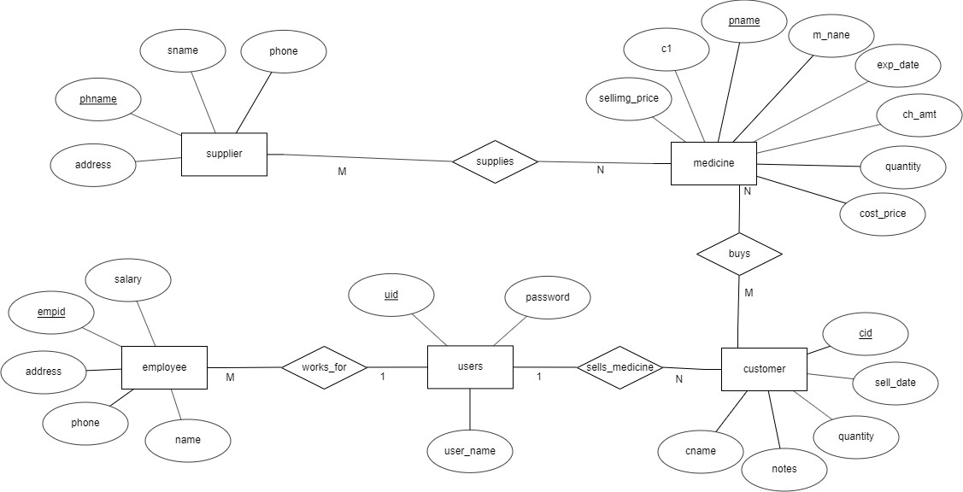

###### Figure 3.2 Entity Relationship Diagram

The figure 3.2 shows ER diagram of pharmacy database management which has various relationship ‘supplies’, ‘buys’, ‘sells_medicines’, and ‘works_for’ among all the relations. It shows how each table is related to other and helps to understand structure and working in a better way.

It also shows the cardinality of each relation in respective relationships. It shows two different cardinality 1:1 and M:N. For example, cardinality of supplier and medicine is M:N with relation ‘supplies’.

# IMPLEMENTATION

* 1. **Table of content**
     1. **TableName:** Employee

|  |  |  |  |
| --- | --- | --- | --- |
| **Fieldname** | **Datatype** | **Length** | **Key** |
| Emp_id | Integer | 30 | Primary |
| Name | Varchar | 30 |  |
| Phone | Text |  |  |
| Address | Varchar | 30 |  |
| Salary | Decimal | 5,2 |  |

Table: 4.1.1 shows the structure of table employee which has five attributes: Emp_id , name , phone, address and salary. Emp_id is a primary key here.

* + 1. **TableName:** Medicine

|  |  |  |  |
| --- | --- | --- | --- |
| **Fieldname** | **Datatype** | **Length** | **Key** |
| M_name | Varchar | 9 | Primary |
| Exp_date | Varchar | 30 |  |
| Ch_amt | Varchar | 30 |  |
| Quantity | Integer | 30 |  |
| Costprice | Decimal | 5,2 |  |
| Sellingprice | Decimal | 5,2 |  |
| C1 | Varchar | 30 |  |
| P_name | Varchar | 30 | Referene |

Table 4.1.2 shows the structure of table medicine which has eight attributes: m_name, exp_date, ch_amt, quantity, cost price, selling price, c1 and p_name. m_name is a primary key here and p_name is reference key from table supplier.

* + 1. **TableName:** Customer

|  |  |  |  |
| --- | --- | --- | --- |
| **Fieldname** | **Datatype** | **Length** | **Key** |
| Cid | Integer | 3 | Primarykey |
| Cname | Varchar | 30 |  |
| Selldate | Date |  |  |
| Quantity | Integer | 30 |  |
| Total | Decimal | 5,2 |  |

Table: 4.1.3 shows the structure of table customer which has five attributes: cid, cname, sell date, quantity and total. cid is a primary key here.

* + 1. **TableName:** Supplier

|  |  |  |  |
| --- | --- | --- | --- |
| **Fieldname** | **Datatype** | **Length** | **Key** |
| Phname | Varchar | 30 | Primary |
| Sname | Varchar | 30 |  |
| Phone | Text |  |  |
| Address | Varchar | 30 |  |
| Phid | Varchar | 30 |  |

Table: 4.1.4 show the structure of table supplier which has five attributes: phname, sname, phone, address and phid. Phname is a primary key here.

* + 1. **Table Name:** User

|  |  |  |  |
| --- | --- | --- | --- |
| **Fieldname** | **Datatype** | **Length** | **Key** |
| U_id | Integer | 30 | Primary |
| Username | Varchar | 30 |  |
| Password | Varchar | 30 |  |

Table: 4.1.5 shows the structure of table user/admin which has three attributes: u_id, username and password .U_id is a primary key here.

#### Code for PHP connection

$dbhost=”localhost” //Database server name

$db=”medshop” //Name of database

$dbuser=”root” //Database username

$dbpass=”” //Database password

//Establishing the connection

$con= mysqli_connect($dbhost,$db,$dbuser,$dbpass); if(!$con)

{

die(“Connection failed:”.mysqli_connect_error());

}

//Perform all the desired operations Mysqli_close($con);

//Closing the established connection

The above code of PHP is used to connect the server. The main reason to use this is, for server side programing. Using this we can interact with many databases.

#### Trigger

A Database trigger is a procedural code that is automatically executed in response to certain events on a particular table in a database. The trigger is mostly used for maintaining the integrity of the information on the database. Triggers help the database designer ensure certain actions, such as maintaining an audit file, are completed regardless of which program or user makes changes to data.

The trigger statement used in this project is:

DELIMITER $$

CREATE TRIGGER ’datetrig’ BEFORE INSERT ON ‘medsell’ FOR EACH ROW SET

new.selldate=now

$$DELIMITER;

The above-mentioned trigger is used in this project to store the time at which the bill is generated.

#### Stored procedure

A stored procedure is a subroutine available to applications that access a relational database management system (RDBMS). Stored procedure may return a result set’s,i.e., the results of a SELECT statement. Such result sets can be processed using cursors, by other stored procedures, by associating a result-set locator, or by applications. Stored procedures may also contain declared variables for processing data and cursors that allow it to loop through multiple rows in a control statement typically a table. Stored-procedure flows include IF, WHILE, LOOP, REPEAT, CASE statements and more.

Stored procedures can receive variables, return results, or modify variables and return them, depending on where and how the variable is declared.

The stored procedure statement used in this project is:

CREATE DEFINER=’root’@’localhost’ PROCEDURE ‘dispuser’ () NO SQL Select * from users

$$DELIMITER;

The above-mentioned stored procedure code is used in this project to display the list of users/admins.

# RESULTS AND SNAPSHOTS



Figure 5.1 Login Page

Figure 5.1 shows the login page where the admin has to enter username and password to go to the next page i.e., Home page.

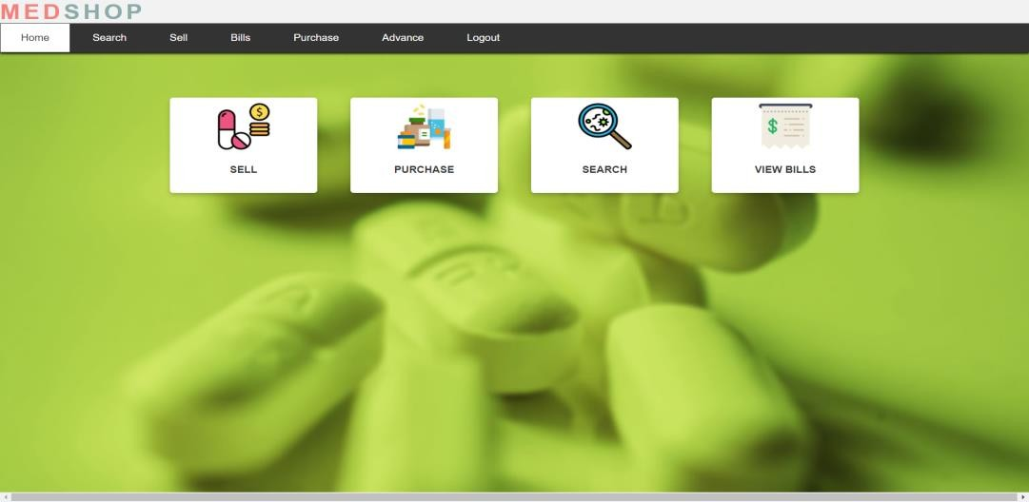

Figure 5.2 Home Page

Figure 5.2 shows page that provides all the options required by user/admin.

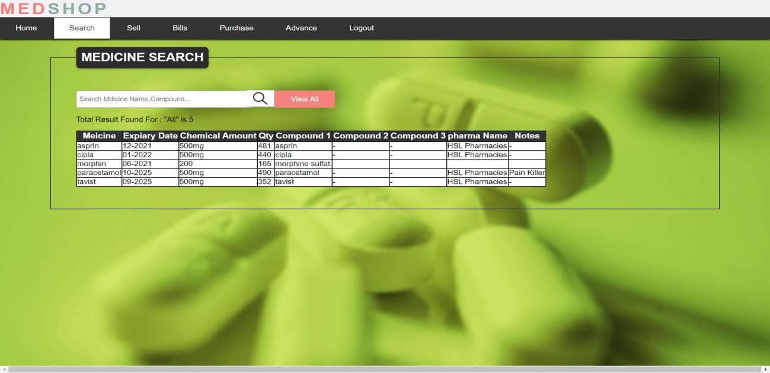

Fig 5.3 Details of Products

Figure 5.3 shows the page which displays all the information of all products. It also has option to search single product by its name.

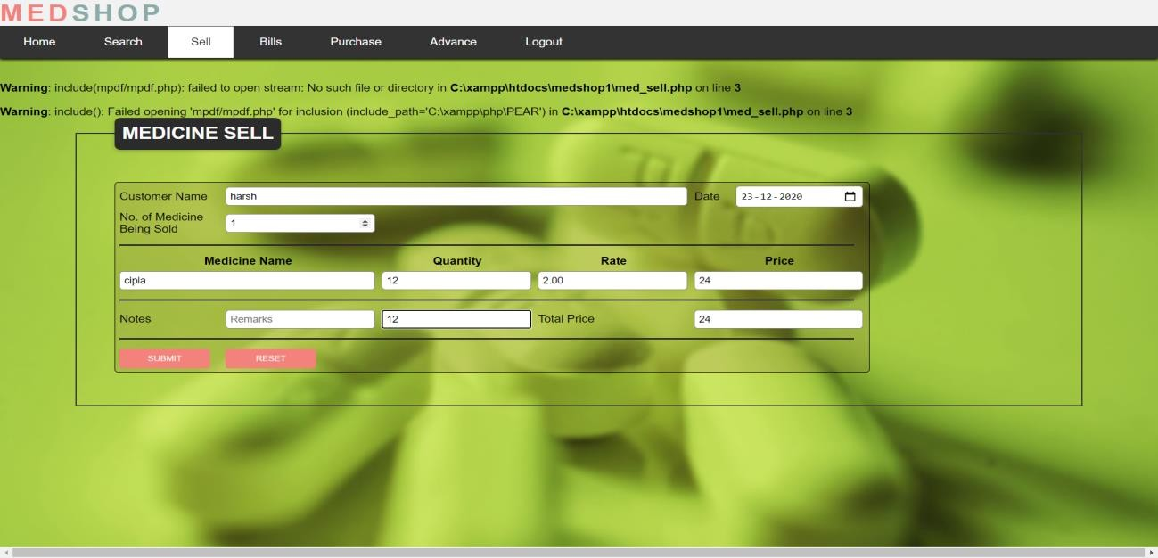

Figure 5.4 Customer details

Figure 5.4 is the page is used to gather the details of customers and their products.

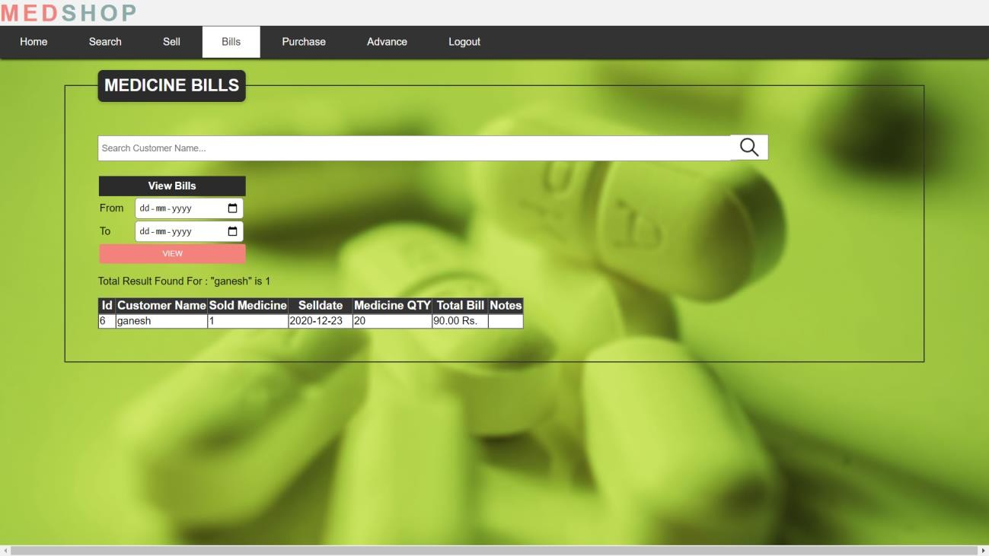

##### Figure 5.5 Bill generated using customer name

Figure 5.5 shows list of bills generated using the customer name.

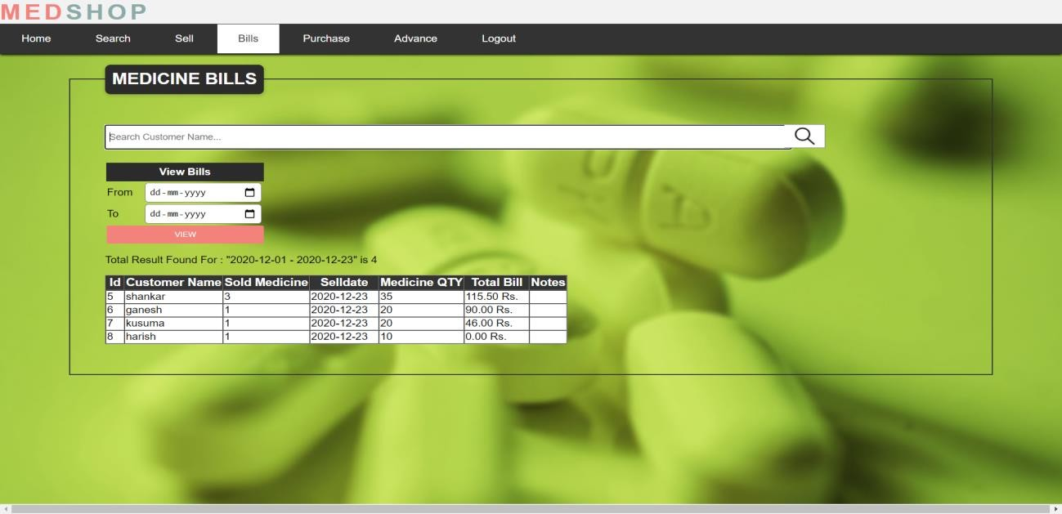

Figure 5.6 Bill generated using date of billing Figure 5.6 shows the list of bill generated using date of billing.

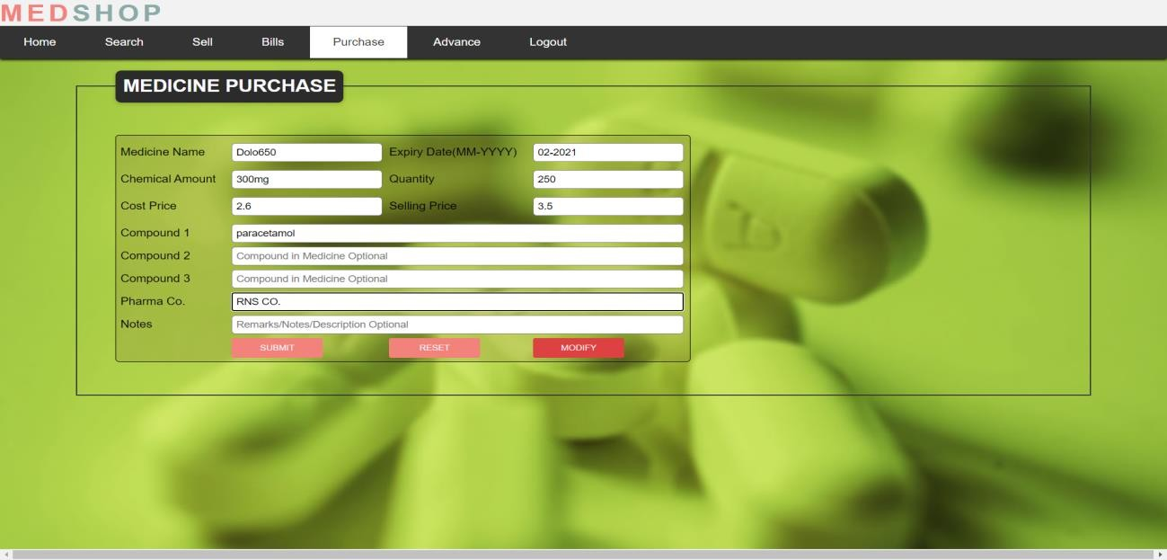

Figure 5.7 Addition of products

Figure 5.7 shows page for adding products where the admin has to enter the required details of the product. It has the option to reset and modify the details of existing products.

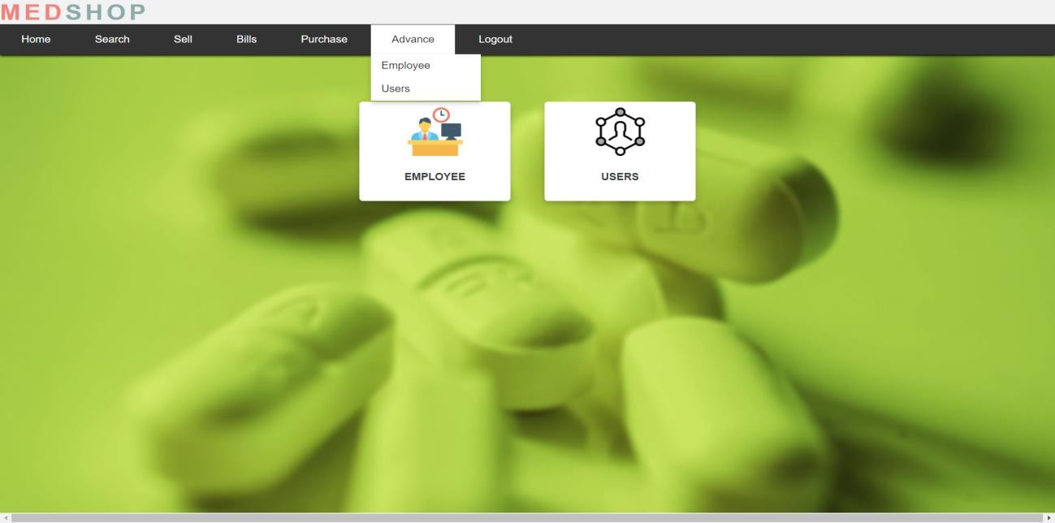

Figure 5.8 Details

Figure 5.8 shows the page that has options to view and edit employees and users.

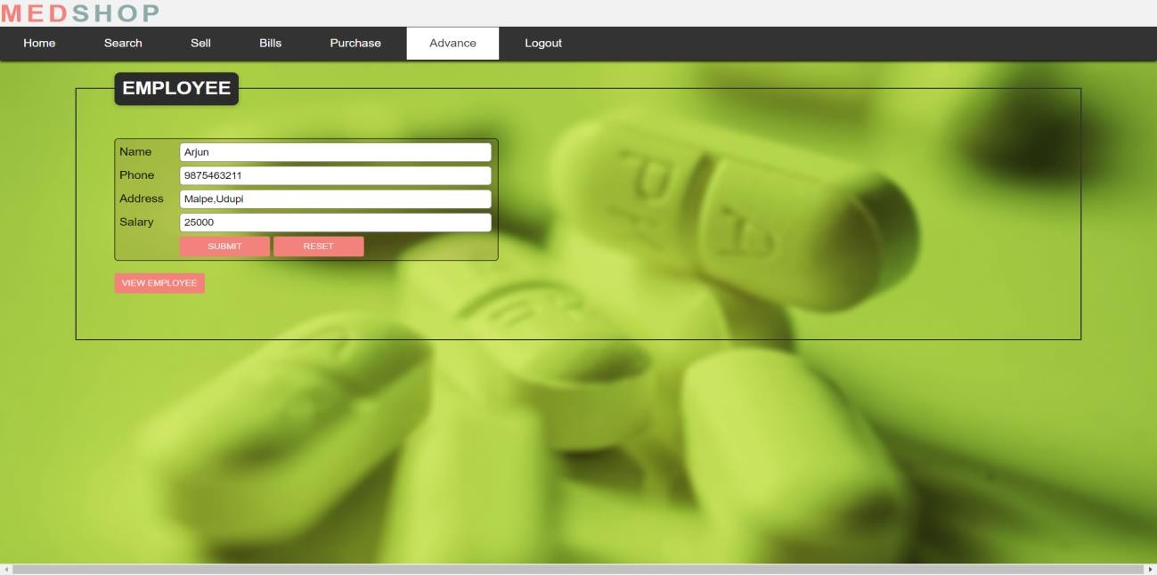

Figure 5.9 Addition of Employee

Figure 5.9 is the page to enter details of employees. It has option to view the details of employees.

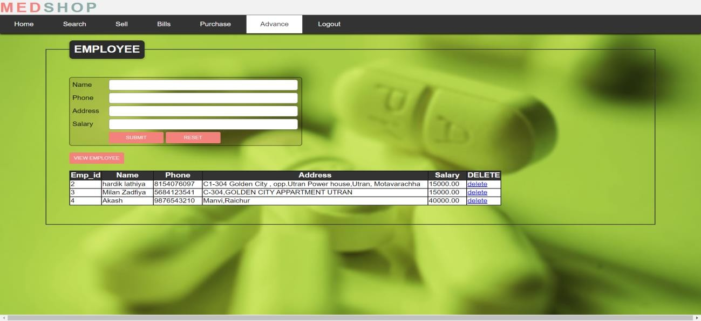

Figure 5.10 List of Employee

Figure 5.10 shows the list of all employees and their details. It also has the option to delete the employee.

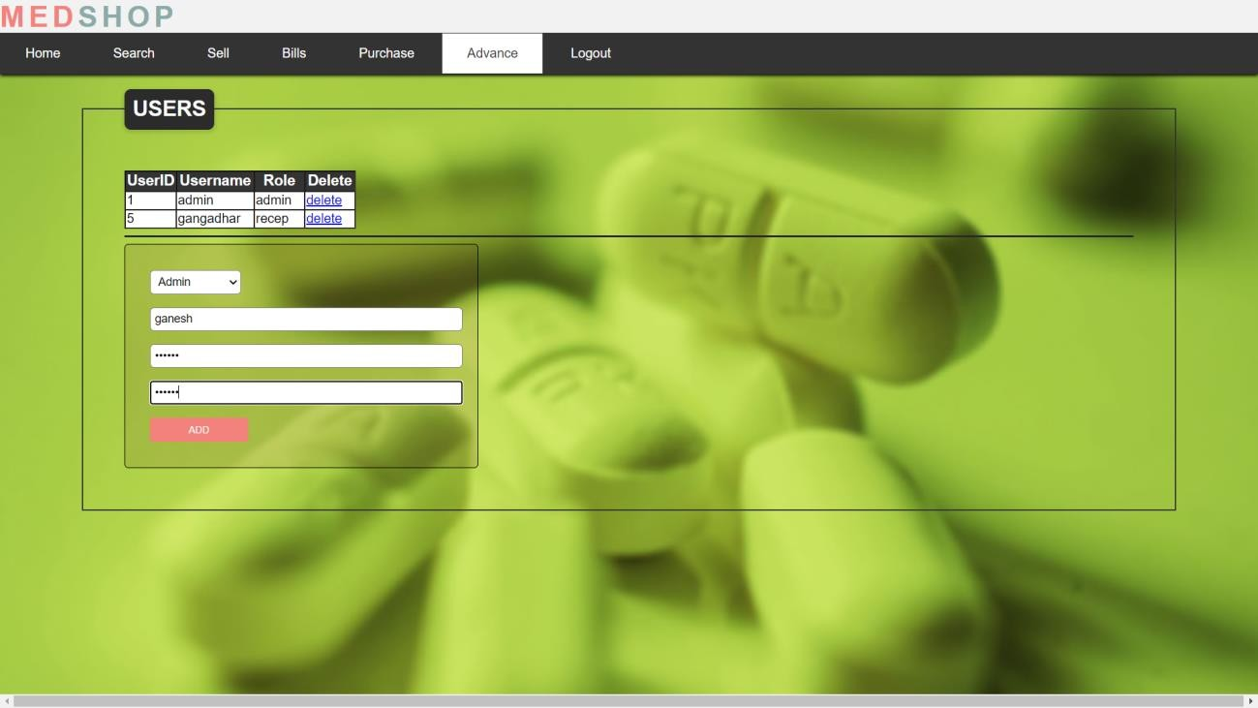

Figure 5.11 Addition of new user/admin

Figure 5.11 is the page that allows the admin to add new user in which username and password of new user has to be entered. It also has the option to delete the existing users.

# TESTING

System testing of software or hardware is testing conducted on a complete, integrated system to evaluate the system’s compliance with its specified requirements. System testing falls within the scope of black box testing and as such should require no knowledge of the inner design of the code or logic.

Two types of testing are:

1. Unit testing
2. Integration testing

|  |  |  |  |  |
| --- | --- | --- | --- | --- |
| **Functionality** | **Action** | **Expected result** | **Actual result** | **Test result** |
| Accepting user input for login | Login is clicked | Should enter the home page | Entering home page | Pass |
| Not accepting different username and password | Login is clicked | Should show error saying invalid | Shows error message | Pass |
| To view all the present admins | Add is clicked | Should displayall users | Displaying all users | Pass |
| To add new user/admin | Add is clicked | Should display added user | Displays updated user table | Pass |

Page 22

|  |  |  |  |  |
| --- | --- | --- | --- | --- |
| To delete existing user | Delete is clicked | Should delete the user | Deletes the user | Pass |
| To display existing products | View is clicked | Should display the details of the all products | Display details of products | Pass |
| To add, delete or update new or existing  product | Add/Delete/Update Is clicked | Should take to add/delete/update page | Successfully add/delete/ update product | Pass |
| To display existing employee | View is clicked | Should displayall details of all employee | Displays details of all employees | Pass |
| To add/delete the employee | Add/delete is clicked | Should add/delete the employee | Successfully adds/deletes the employee | Pass |
| To display error if product is not available | View is clicked | Should display error if product is not available | Displays error | Pass |
| To generate bill of the required customer | Click on bill and enter the customer name | Should generate the bill of respective customer | Displaying the bill | Pass |
| Logout from account | Click on logout | Should log you out and take you to login page | Takes you to login page | Pass |

# CONCLUSION AND FURURE ENHANCEMENT

#### Conclusion

The project titled as "Pharmacy Database Management" is a web-based application. This software provides facility of viewing the product details, ordering the required number of products by giving the products, bills and customer information, updating the quantity of products and deletion productions, employees. This software is developed with scalability in mind. Additional modules can be easily added when necessary. The software is developed with modular approach. All modules in the system have been tested with valid data and invalid data and everything work successfully. Thus, the system has fulfilled all the objectives identified.

The project has been completed successfully with the maximum satisfaction of the organization. The constraints are met and overcome successfully. The system is designed as, like it was decided in the design phase. The project gives good idea on developing a full-fledged application satisfying the requirements. Hence the software has proved efficiently.

#### Future Enhancement

* + - **Space Constraints**: It may not be possible to record all the desired information at the same place e.g. large number of registers will be needed. As the information grows number of registers having data also increases.
    - **Memory Lapse**: To easily access the record within the registers some alternate method is also needed, which will keep track of each register containing information.
    - **Maintaining copies**: It is not easy to maintain the multiple copies of the database, because all are maintained manually.
    - **Indexing**: It is difficult to index the information stored in the manual helpline database.
    - **Searching:** To find any album from manual helpline database is not so easy and is time

consuming. As the number of records increase the average time required for the search also increases.

* + - **Report generation**: People need reports, like list of students, list of sub-categories etc. It will take a lot effort as well as time to perform the job manually.

1. RamezElmasri and Shamakant B. Navathe, “Database system Models, Languages, Design and Application Programming”, 6th Edition, Pearson, 2017.
2. Ramakrishna and Gehrke, “Database management system”, 3rd Edition McGraw Hill 2014.
3. Silberschatzzkorth and Sudhershan, “Database system concepts”, 6th Edition McGraw Hill, 2013.
4. Coronel, Morris, and Rob “Database Principles Fundamentals of Design, Implementation and Management” Cengage Learning 2012.
5. Abraham Silberchatz, Henry korth and S.Sudarshan, “Database System Concepts”, McGraw Hill Education, 2010.
6. Jeffery.D.Ullman, “Principles of database system”, Financial times Prentice Hall 2nd Revised edition, 1982.
7. PHP tutorials, retrieved from [http://www.youtube.com](http://www.youtube.com/)
8. Front-end retrieved from https:/[/www](http://www.w3schools.com/).[w3schools.com.](http://www.w3schools.com/)
9. PHP connection, retrieved from https:/[/www](http://www.phptpoint.com/).[phptpoint.com.](http://www.phptpoint.com/)
10. E-R Diagram construction, retrieved from https:/[/www](http://www.erdplus.com/).[erdplus.com.](http://www.erdplus.com/)
11. Images and schema diagram, retrieved from https:/[/www](http://www.google.com/).[google.com.](http://www.google.com/)